Section 5-5 Proving Right Triangles Congruent
Content Objective: Students will use right triangle congruence theorems to solve problems.

Vocabulary: LL, HA, LA, HL,

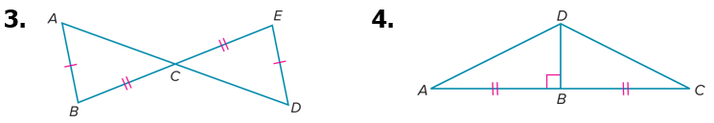
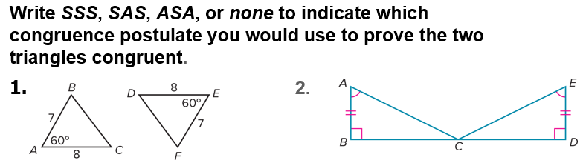
Warm up exercise

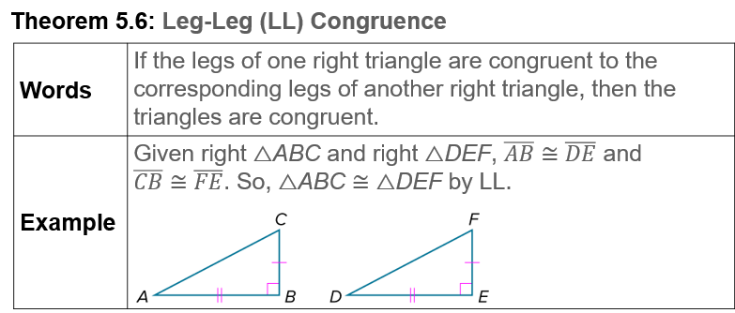
Notes…

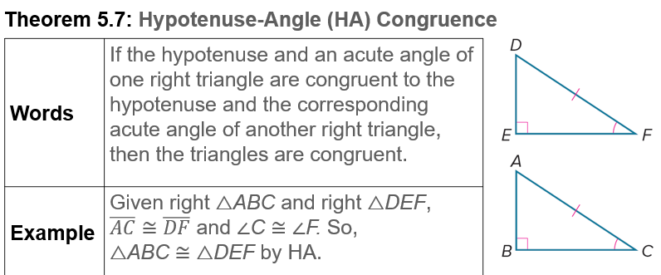
Notes…

Example #1
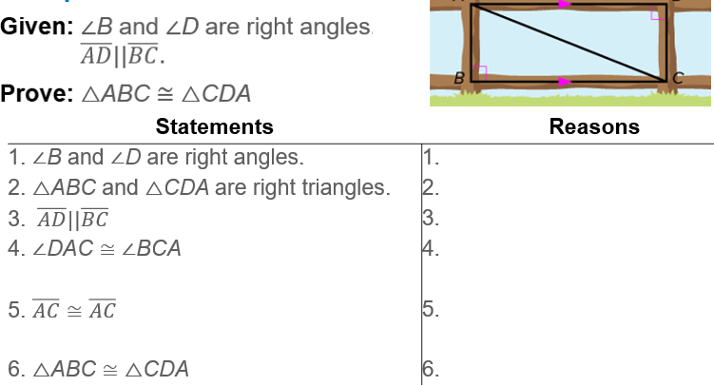

Exit Ticket…

