Section 3-9 Proving Lines Parallel
Content Objective: Students identify and use parallel lines by using angle relationships.

Vocabulary: Converse of corresponding, alternate int., alternate ext., consecutive angles

Example #1  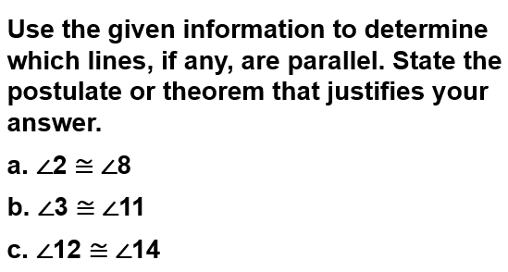 | 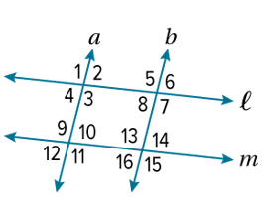

Example #2   | 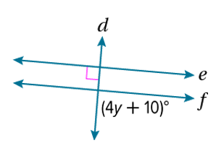

Example #2a  Check  a. Find the value of x so that 𝓂 ∥ 𝓃. Identify the postulate or theorem you used. | 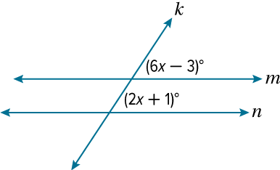

Example #2b  b. Find m∠LMN so that 𝒶 ∥ 𝒷. Identify the postulate or theorem you used. | 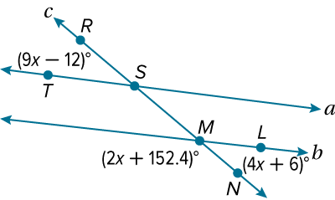

Example #3  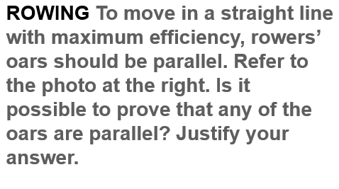 | 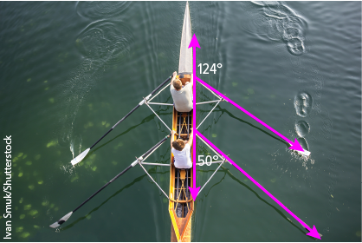

Example #3a  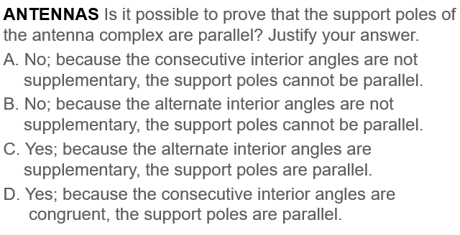 | 