Section 8-2 Similar Polygons
Content Objective: Students solve problems using the definition of similar polygons.

Vocabulary: similar polygons, corresponding sides, proportion, similar ratio,

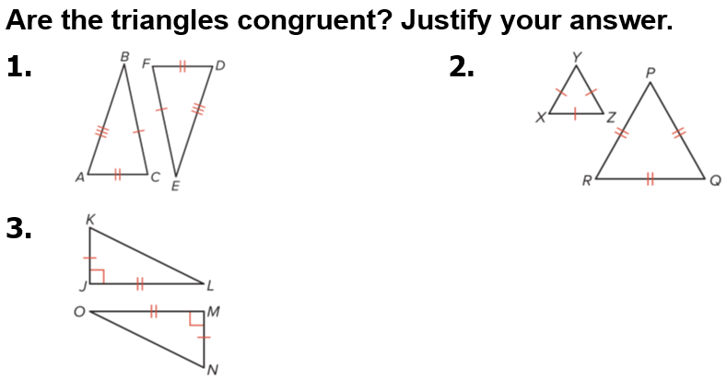  Warm up exercise | 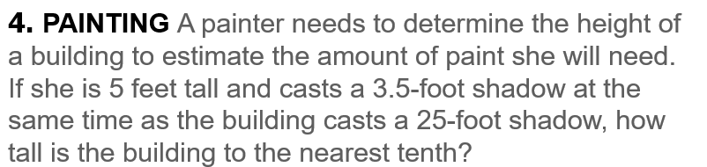

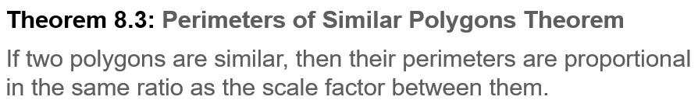
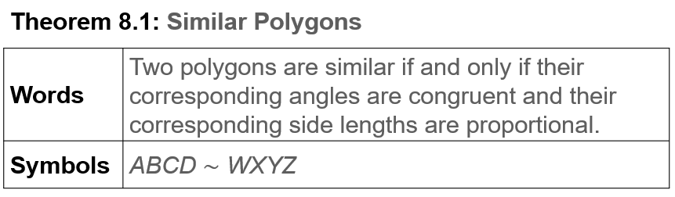
Notes…

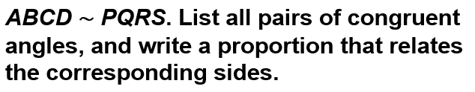  Example #1 | 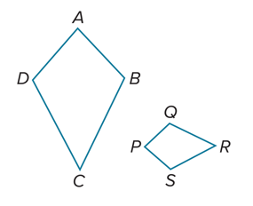

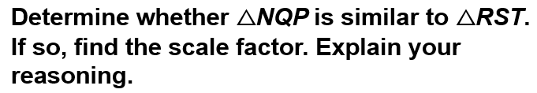  Example #2 | 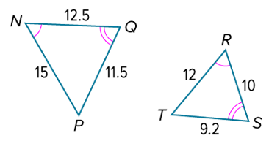

Example #3 | 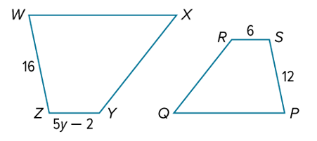

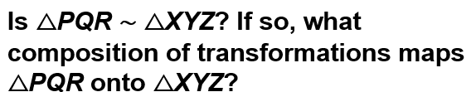  Example #4 | 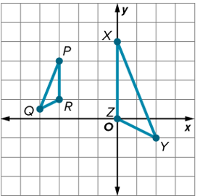

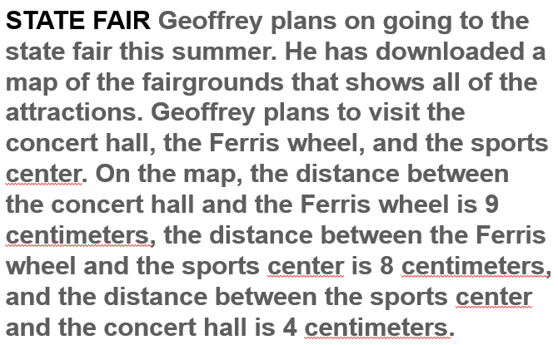  Example #5 |   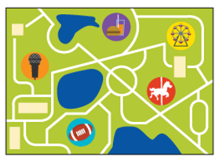

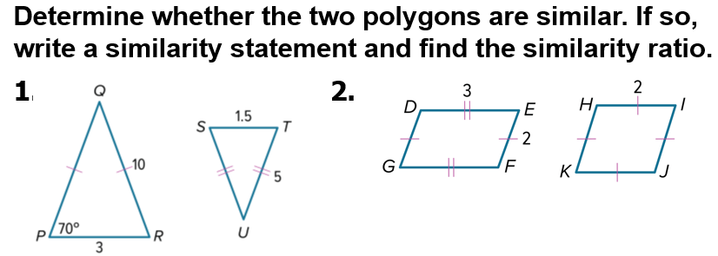
Exit Ticket
